**Unit-II**

**Types of DC Generators**

Generally [DC generators](https://www.electrical4u.com/principle-of-dc-generator/) are classified according to the ways of excitation of their fields. There are three methods of excitation.

1. Field coils excited by permanent magnets – Permanent magnet DC generators.
2. Field coils excited by some external source – Separately excited DC generators.
3. Field coils excited by the generator itself – Self excited DC generators.

A brief description about these generators are given below.

**Permanent Magnet DC Generator**

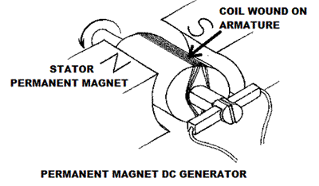

When the [flux](https://www.electrical4u.com/what-is-flux-types-of-flux/) in the [magnetic circuit](https://www.electrical4u.com/what-is-magnetic-field/#Magnetic-Circuit) is established by the help of permanent magnets then it is known as Permanent magnet DC generator.

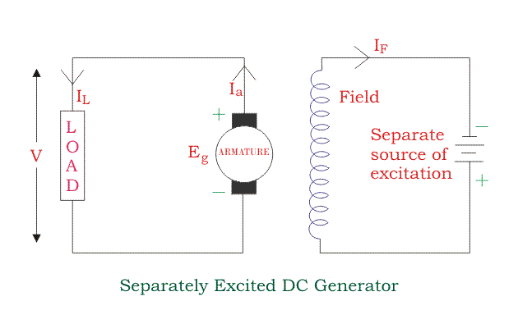It consists of an armature and one or several permanent magnets situated around the armature. This type of DC generators generates very low power. So, they are rarely found in industrial applications. They are normally used in small applications like dynamos in motor cycles.

**Separately Excited DC Generator**

These are the generators whose field magnets are energized by some external DC source such as [battery](https://www.electrical4u.com/battery-history-and-working-principle-of-batteries/).  
A circuit diagram of separately excited DC generator is shown in figure.  
Ia = Armature current  
IL = Load current  
V = Terminal voltage  
Eg = Generated emf

[Voltage drop](https://www.electrical4u.com/voltage-drop-calculation/) in the armature = Ia × Ra (Ra is the armature [resistance](https://www.electrical4u.com/electrical-resistance-and-laws-of-resistance/))

Ia = IL

Then,

Voltage across the load, V = Eg - IaRa

Power generated, Pg = EgIa watts

Power delivered to the external load, PL = VIL watts

**Self-excited DC Generators**

These are the generators whose field magnets are energized by the [current](https://www.electrical4u.com/electric-current-and-theory-of-electricity/) supplied by themselves. In these types of machines field coils are internally connected with the armature. Due to residual flux in the poles, when the armature is rotating some emf is induced. Hence some induced current is produced. This small current flows through the field coil as well as the load and thereby strengthening the pole flux. As the pole flux strengthened, it will produce more armature emf, which causes further increase of current through the field. This increased field current further raises armature emf and this cumulative phenomenon continues until the excitation reaches to the rated value.

According to the position of the field coils the [self-excited DC generators](https://www.electrical4u.com/self-excited-generators/) may be classified as…

1. Series wound generators
2. Shunt wound generators
3. Compound wound generators

**Series Wound Generator**

In this type of generator, the field winding is connected in series with armature as shown in figure below. So, whole current flows through the field coils as well as the load. As series field winding carries full load current it is designed with relatively few turns of thick wire. The [electrical resistance](https://www.electrical4u.com/electrical-resistance-and-laws-of-resistance/) of series field winding is therefore very low (nearly 0.5Ω). Let,

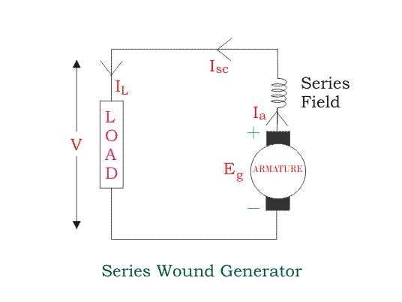  
Rse = Series winding resistance  
Ise = Current flowing through the series field  
Ra = Armature [resistance](https://www.electrical4u.com/electrical-resistance-and-laws-of-resistance/)  
Ia = Armature current  
IL = Load current  
V = Terminal voltage  
Eg = Generated emf

Then,

Ia = IL = Ise

[Voltage drop](https://www.electrical4u.com/voltage-drop-calculation/) in the armature = Ia × Ra

[Voltage drop](https://www.electrical4u.com/voltage-drop-calculation/) in the series field = Ise × Rse = Ia × Rse

Then,

Voltage across the load, V = Eg - Ia (Ra+ Rse)

Power generated, Pg = EgIa watts

Power delivered to the external load, PL = VIL watts

**Shunt Wound DC Generators**

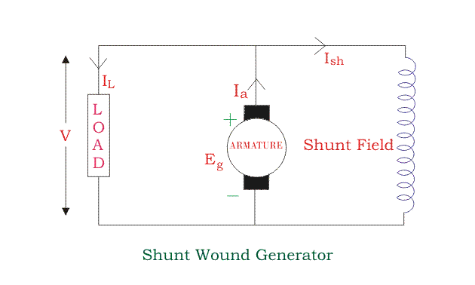In these type of DC generators the field windings are connected in parallel with armature conductors as shown in figure below. In shunt wound generators the voltage in the field winding is same as the voltage across the terminal.

Let,

Rsh = Shunt winding [resistance](https://www.electrical4u.com/electrical-resistance-and-laws-of-resistance/)  
Ish = Current flowing through the shunt field   
Ra = Armature [resistance](https://www.electrical4u.com/electrical-resistance-and-laws-of-resistance/)  
Ia = Armature current  
IL = Load current  
V = Terminal voltage  
Eg = Generated emf

Here armature current Ia is dividing in two parts,

One is shunt field current Ish and

The other is the load current IL.  
So,

Ia = IL + Ish

The power delivered to the load will be maximum, when the load current (IL) will be maximum. So, it is required to keep shunt field current as small as possible. For this purpose the [resistance](https://www.electrical4u.com/electrical-resistance-and-laws-of-resistance/) of the shunt field winding generally kept high by wound the shunt field with thin wire and more turns.  
Then,

Shunt field current, Ish =

[Voltage drop](https://www.electrical4u.com/voltage-drop-calculation/) in the armature = Ia × Ra

Voltage across the load, V = Eg - Ia Ra

Power generated, Pg = EgIa watts

Power delivered to the external load, PL = VIL watts

**Compound Wound DC Generator**

Compound wound generators have both series field winding and shunt field winding. One winding is placed in series with the armature and the other is placed in parallel with the armature. This type of DC generators may be of two types- short shunt compound wound generator and long shunt compound wound generator.

**Short Shunt Compound Wound DC Generator**

In this generator parallel combination of shunt field winding and armature is in series with series field winding as shown in figure.

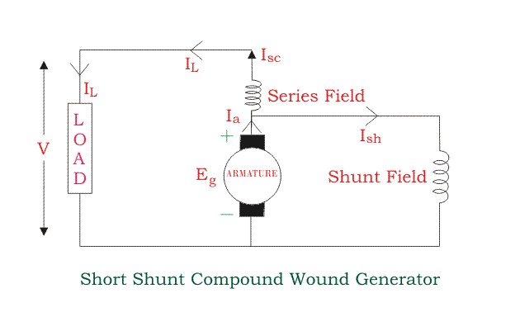

Series field current,

Ise = IL

Shunt field current,

Ish =

Armature current,

Ia = IL + Ish

Voltage across the load,

V = Eg - Ia Ra - IseRse

Power generated,

Pg = EgIa watts

Power delivered to the external load,

PL = VIL watts

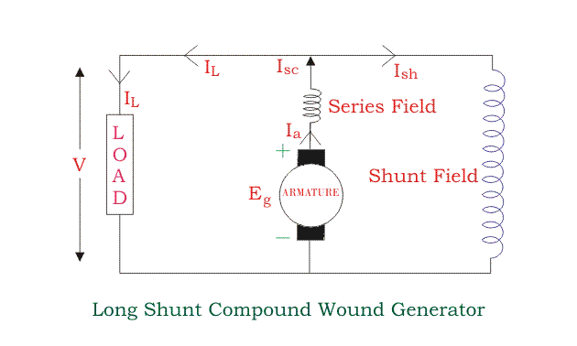**Long Shunt Compound Wound DC Generator**

The In this generator series combination of series field winding and armature is in parallel with shunt field winding as shown in figure

Shunt field current,

Ish =

Armature current, Ia = series field current, Ise = IL + Ish

Voltage across the load,

V = Eg - Ia (Ra+ Rse)

Power generated,

Pg = EgIa watts

Power delivered to the external load,

PL = VIL watts

In a compound wound generator, the shunt field is stronger than the series field. When the **series field assists the shunt field**, generator is said to be **commutatively compound wound**.

On the other hand if **series field opposes the shunt field**, the generator is said to be **differentially compound wound**.

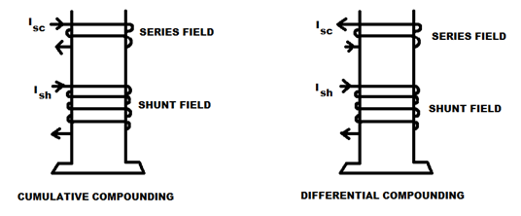

# Characteristics of DC Generators

Generally, following three characteristics of [DC generators](http://www.electricaleasy.com/2012/12/basic-construction-and-working-of-dc.html) are taken into considerations: (i) Open Circuit Characteristic (O.C.C.), (ii) Internal or Total Characteristic and (iii) External Characteristic. These **characteristics of DC generators** are explained below.

### 1. Open Circuit Characteristic (O.C.C.) (E0/If)

Open circuit characteristic is also known as **magnetic characteristic** or **no-load saturation characteristic**. This characteristic shows the relation between generated emf at no load (E0) and the field current (If) at a given fixed speed. The O.C.C. curve is just the magnetization curve and it is practically similar for all [type of generators](http://www.electricaleasy.com/2012/12/classifications-of-dc-machines.html).

The data for O.C.C. curve is obtained by operating the generator at no load and keeping a constant speed. Field current is gradually increased and the corresponding terminal voltage is recorded. The connection arrangement to obtain O.C.C. curve is as shown in the figure below. For shunt or series excited generators, the field winding is disconnected from the machine and connected across an external supply.

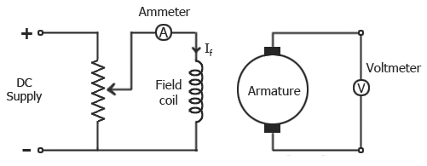

Now, from the [emf equation of dc generator](http://www.electricaleasy.com/2012/12/emf-and-torque-equation-of-dc-machine.html), we know that Eg = kɸ. Hence, the generated emf should be directly proportional to field flux (and hence, also directly proportional to the field current).

However, even when the field current is zero, some amount of emf is generated (represented by OA in the figure below). This initially induced emf is due to the fact that there exists some residual magnetism in the field poles. Due to the residual magnetism, a small initial emf is induced in the armature. This initially induced emf aids the existing residual flux, and hence, increasing the overall field flux. This consequently increases the induced emf. Thus, O.C.C. follows a straight line. However, as the flux density increases, the poles get saturated and the ɸ becomes practically constant. Thus, even we increase the If further, ɸ remains constant and hence, Eg also remains constant. Hence, the O.C.C. curve looks like the B-H characteristic.

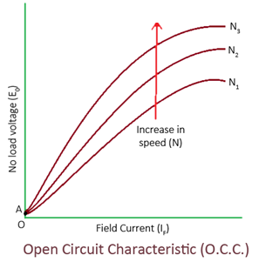

The above figure shows a typical no-load saturation curve or open circuit characteristics for all types of DC generators.

### 2. Internal or Total Characteristic (E/Ia)

An internal characteristic curve shows the relation between the on-load generated emf (Eg) and the armature current (Ia). The on-load generated emf Eg is always less than E0 due to the [armature reaction](http://www.electricaleasy.com/2013/01/armature-reaction-in-dc-machines.html). Eg can be determined by subtracting the drop due to demagnetizing effect of armature reaction from no-load voltage E0. Therefore, internal characteristic curve lies below the O.C.C. curve.

### 3. External Characteristic (V/IL)

An external characteristic curve shows the relation between terminal voltage (V) and the load current (IL). Terminal voltage V is less than the generated emf Eg due to voltage drop in the armature circuit. Therefore, external characteristic curve lies below the internal characteristic curve. External characteristics are very important to determine the suitability of a generator for a given purpose. Therefore, this type of characteristic is sometimes also called as **performance characteristic** or **load characteristic**.

Internal and external characteristic curves are shown below for each [type of generator](http://www.electricaleasy.com/2012/12/classifications-of-dc-machines.html).

**Characteristics of Separately Excited DC Generator**

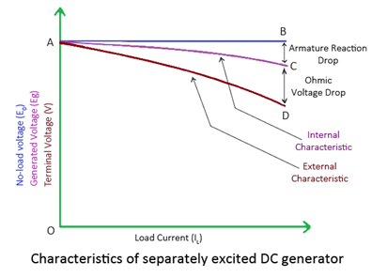

If there is no armature reaction and armature voltage drop, the voltage will remain constant for any load current. Thus, the straight line AB in above figure represents the no-load voltage vs. load current IL. Due to the demagnetizing effect of [armature reaction](http://www.electricaleasy.com/2013/01/armature-reaction-in-dc-machines.html), the on-load generated emf is less than the no-load voltage. The curve AC represents the on-load generated emf Eg vs. load current ILi.e. internal characteristic (as Ia = IL for a separately excited dc generator). Also, the terminal voltage is lesser due to ohmic drop occurring in the armature and brushes. The curve AD represents the terminal voltage vs. load current i.e. external characteristic.

## Characteristics of DC Shunt Generator

To determine the internal and external load characteristics of a DC shunt generator the machine is allowed to build up its voltage before applying any external load. To build up voltage of a shunt generator, the generator is driven at the rated speed by a prime mover. Initial voltage is induced due to residual magnetism in the field poles. The generator builds up its voltage as explained by the O.C.C. curve. When the generator has built up the voltage, it is gradually loaded with resistive load and readings are taken at suitable intervals. Connection arrangement is as shown in the figure below.

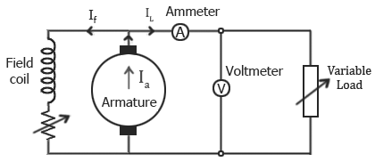

Unlike, separately excited DC generator, here, IL≠Ia. For a shunt generator, Ia=IL+If. Hence, the internal characteristic can be easily transmitted to Eg vs. IL by subtracting the correct value of Iffrom Ia.

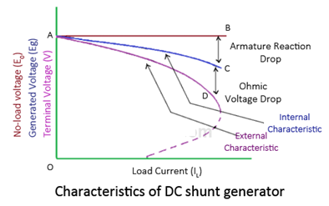

During a normal running condition, when load resistance is decreased, the load current increases. But, as we go on decreasing the load resistance, terminal voltage also falls. So, load resistance can be decreased up to a certain limit, after which the terminal voltage drastically decreases due to excessive armature reaction at very high armature current and increased I2R losses. Hence, beyond this limit any further decrease in load resistance results in decreasing load current. Consequently, the external characteristic curve turns back as shown by dotted line in the above figure.

## Characteristics of DC Series Generator

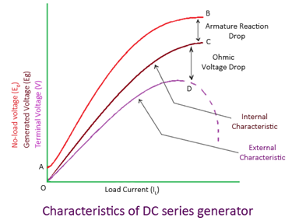

The curve AB in the figure above is identical to open circuit characteristic (O.C.C.) curve. This is because in DC series generators field winding is connected in series with armature and load. Hence, here load current is similar to field current (i.e. IL=If). The curve OC and OD represent internal and external characteristic respectively. In a DC series generator, terminal voltage increases with the load current. This is because, as the load current increases, field current also increases. However, beyond a certain limit, terminal voltage starts decreasing with increase in load. This is due to excessive demagnetizing effects of the armature reaction.

**Characteristics of DC Compound Generator**

The figure below shows the external characteristics of DC compound generators. If series winding amp-turns are adjusted so that, increase in load current causes increase in terminal voltage then the generator is called to be over compounded. The external characteristic for over compounded generator is shown by the curve AB in the below figure.

If series winding amp-turns are adjusted so that, the terminal voltage remains constant even the load current is increased, then the generator is called to be flat compounded. The external characteristic for a flat compounded generator is shown by the curve AC.

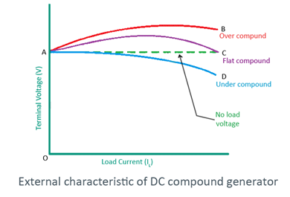

If the series winding has lesser number of turns than that would be required to be flat compounded, then the generator is called to be under compounded. The external characteristics for an under compounded generator are shown by the curve AD.

# [Critical Field Resistance In D.C. Shunt Generator](https://electricallive.com/2015/03/critical-field-resistance-in-dc-shunt.html)

# Consider the field magnetization characteristics of a d.c. shunt generator shown in the Fig. 1.

# https://electricallive.com/wp-content/uploads/2018/04/ccc1114.jpeg

# Fig. 1 Concept of critical resistance

The Fig. 1 shows that generator voltage builds in step till point A. This point is intersection of field resistance line with the open circuit characteristics (O.C.C.). The voltage corresponding to point A is the maximum voltage it can generate. If the slope of field resistance line is reduced by decreasing the field resistance, the maximum voltage generator can build will be higher than that corresponding to point A. Similarly if the slope of field resistance line is increased by increasing the field resistance, the maximum voltage generator can build will be less that that corresponding to point A i.e. corresponding to point B.

If now the slope of the field resistance line is increased in such a way that it becomes tangential to the lower part of the open circuit characteristics. The voltage corresponding to this point is EC. This voltage is just sufficient to drive the current through field resistance so that cumulative process of building the voltage starts. This value of field resistance is called critical resistance denoted as RC, of the shunt field circuit at given speed.

**Note:** If field circuit resistance is more than RC at start then induced e.m.f. fail to drive current through field circuit and generator fails to excite at given speed.

https://electricallive.com/wp-content/uploads/2018/04/ccc1115.jpeg

The critical resistance is the slope of the critical resistance line.

https://electricallive.com/wp-content/uploads/2018/04/ccc1116.jpeg

Similar to the critical resistance there is a concept of critical speed. We know that E ? N. As speed decreases the induced e.m.f. decreases and we get O.C.C. below the O.C.C. at normal speed. If we go on reducing the speed, at a particular speed we will get O.C.C. just tangential to normal field resistance line.

**Note:** This speed at which the machine just excites for the given field circuit resistance is called the critical speed of a shunt generator denoted as NC.

1.1 Practical Determination of RC

Generally data for plotting the open circuit characteristics is given. Plot the characteristics on the graph paper to the scale.

Draw the tangent, to the initial part of this O.C.C. then the slope of this line is the critical resistance for the speed at which the data is given.

**Note:** If speed changes, then the O.C.C. changes hence the value of RC changes.

Now if RC is asked at speed N2, while data for O.C.C. is given at N1. It is known that,

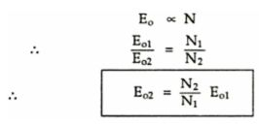

**Note:** Generate the data for O.C.C. at new speed and repeat the procedure to obtain RC.

**Critical Speed**

It is known that as speed changes, the open circuit characteristics also changes, similarly for different shunt field resistances, the corresponding lines are also different.

**Note:** The speed for which the given field resistance acts as critical resistance is called the critical speed, denoted as NC.

Thus if the line is drawn representing given Rsh then O.C.C. drawn for such a speed to which this line is tangential to the initial portion, is nothing but the critical speed NC.

Graphically critical speed can be obtained for given Rsh. The steps are,

1. Drawn O.C.C. for given speed N1.
2. Draw a line tangential to this O.C.C. say OA.
3. Draw a line representing the given Rsh say OP.
4. Select any field current say point R.
5. Draw vertical line from R to intersect OA at S and OP at T.

Then the critical speed NC is,

https://electricallive.com/wp-content/uploads/2018/04/ccc1118.jpeg

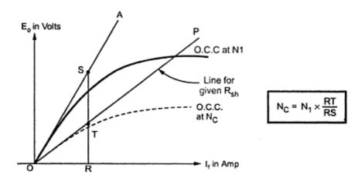

**Fig. 2 Determine critical speed**